**EXP NO 6**Create a simple cloud software application for Payroll Processing System using any Cloud Service Provider to demonstrate SaaS include the necessary fields such as Name of the employee, experience in present org, over all experience, basic pay, HRA, DA, TA, net pay, gross pay etc.

**PROCEDURE**

**STEP 1** GO TO ZOHO.COM

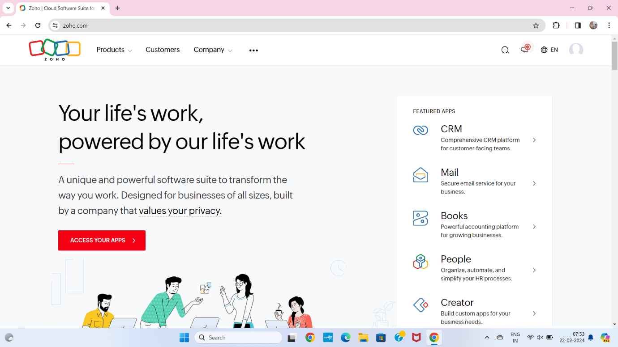

**STEP2** LOGIN TO THE ZOHO.COM

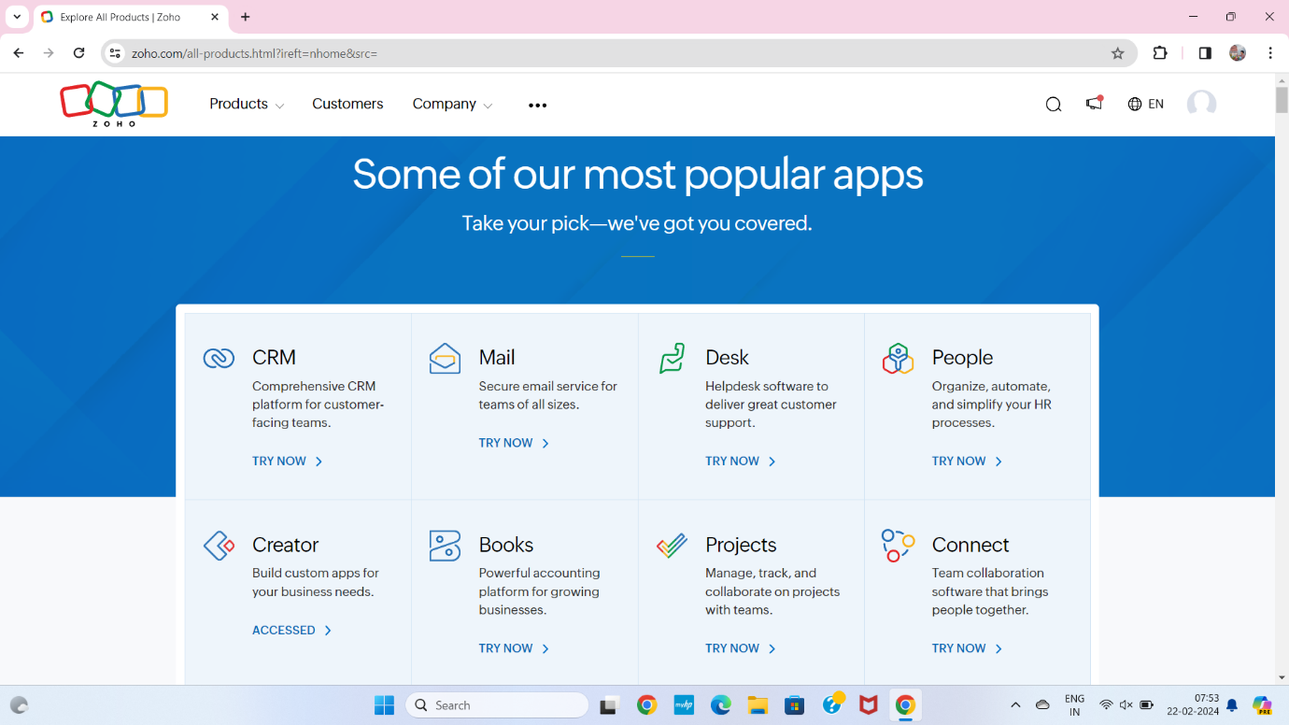

**STEP3**SELECT A CREATE FROM SCRATCH

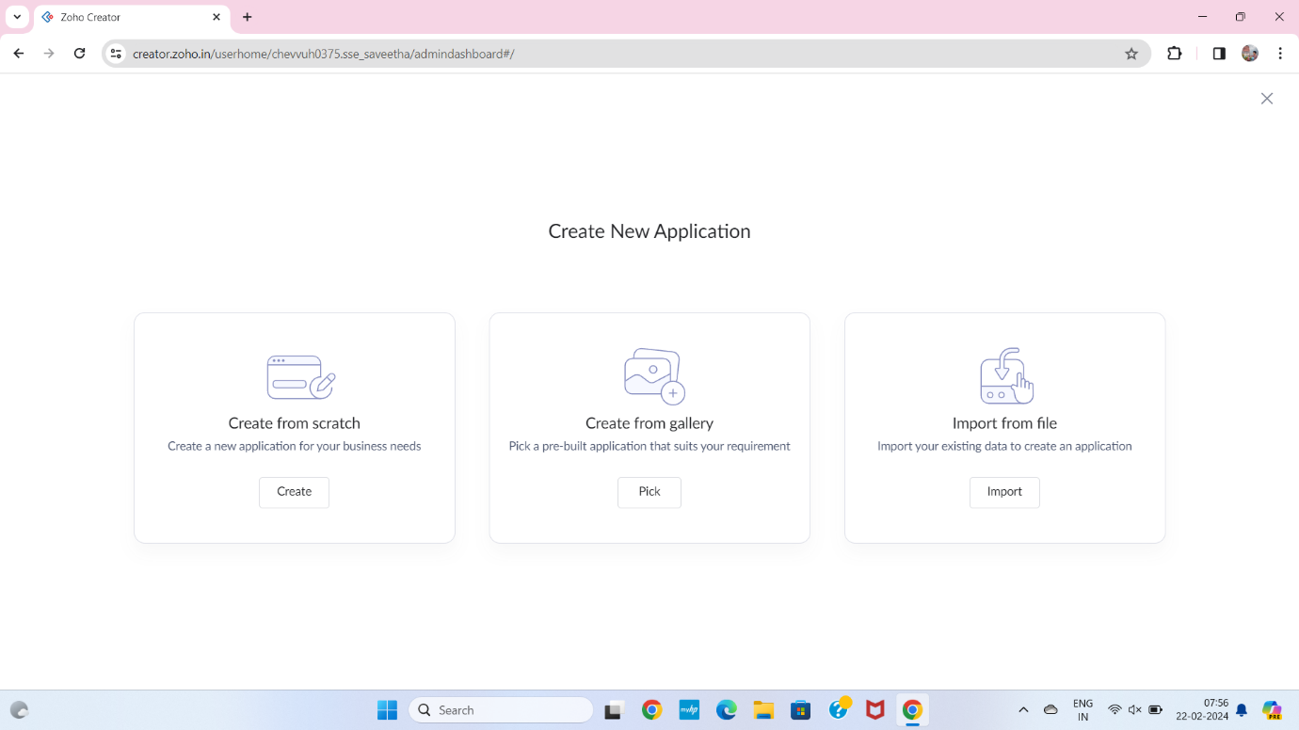

**STEP 4**SELECT APPLICATION NAME AS PAY ROLL PROCESSING SYSTEM

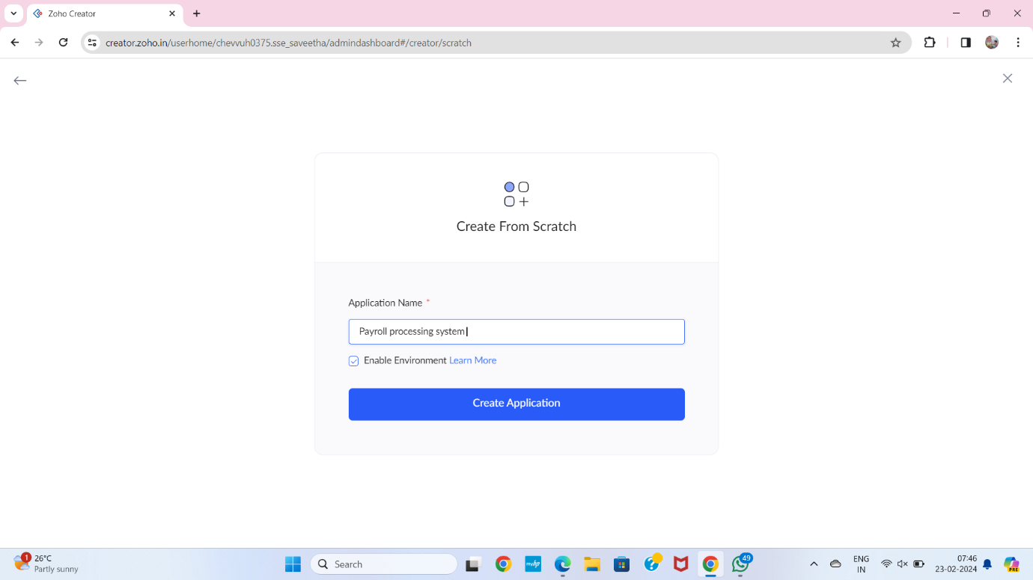

**STEP 5** CREATE A NEW FORM

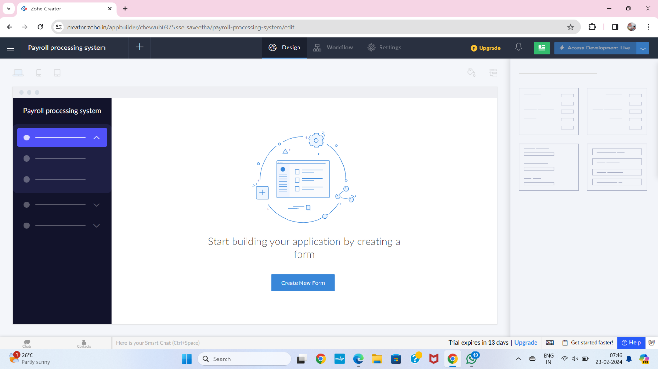

**STEP 6** SELECT BASIC FIELD FROM GIVEN BELOW AND DEVELOP APPLICATION

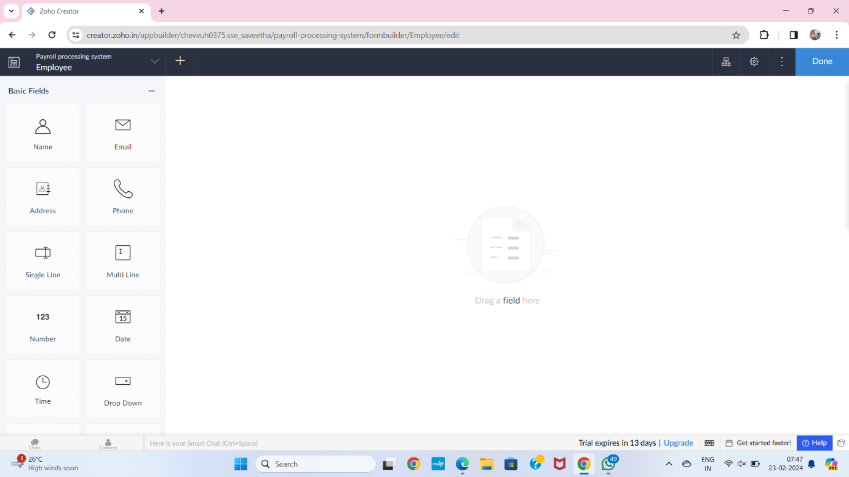

**STEP 7**THE SOFTWARE HASE BEEN CREATEDEMPLOYEE

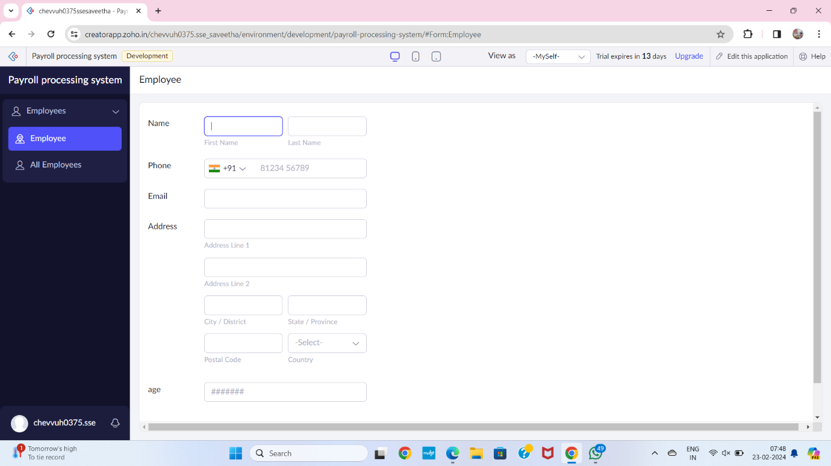

**STEP 8**THE SOFTWARE HASE BEEN CREATEDSALARY

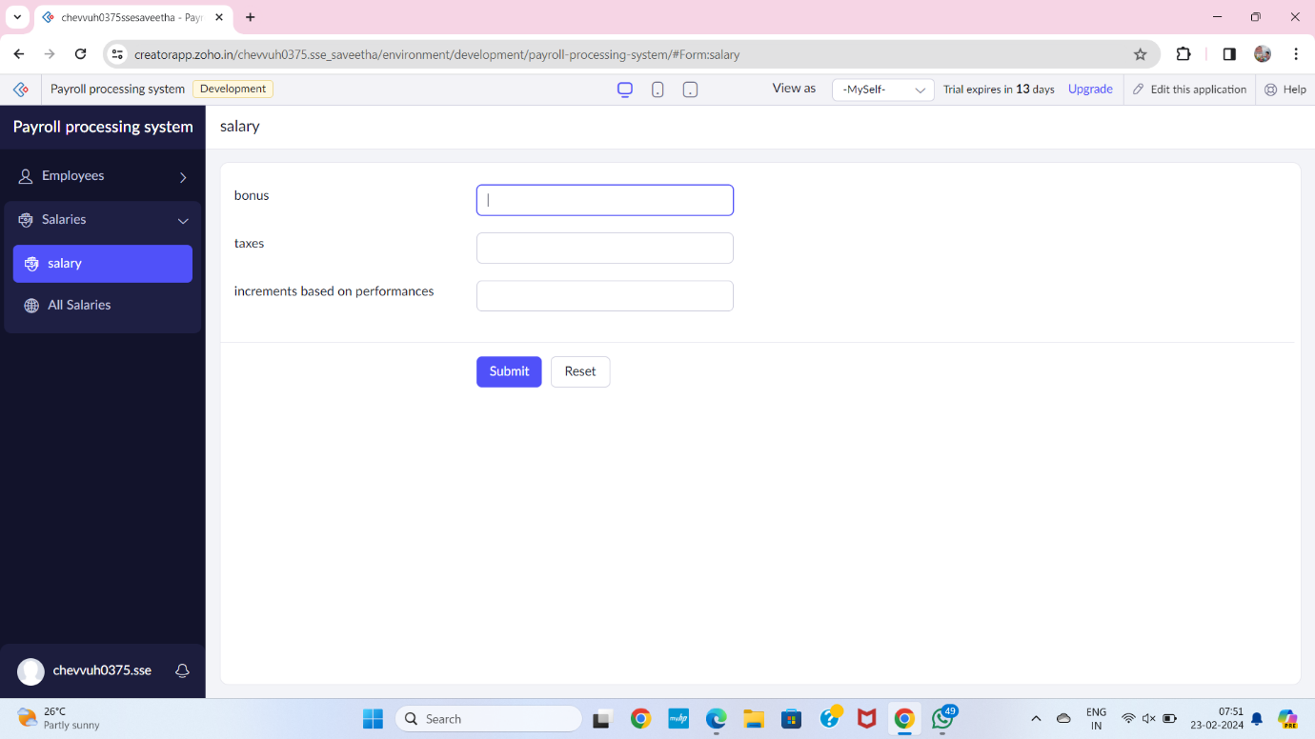

**STEP 9** THE SOFTWARE HASE BEEN CREATEDEXPERIENCE OF WORK

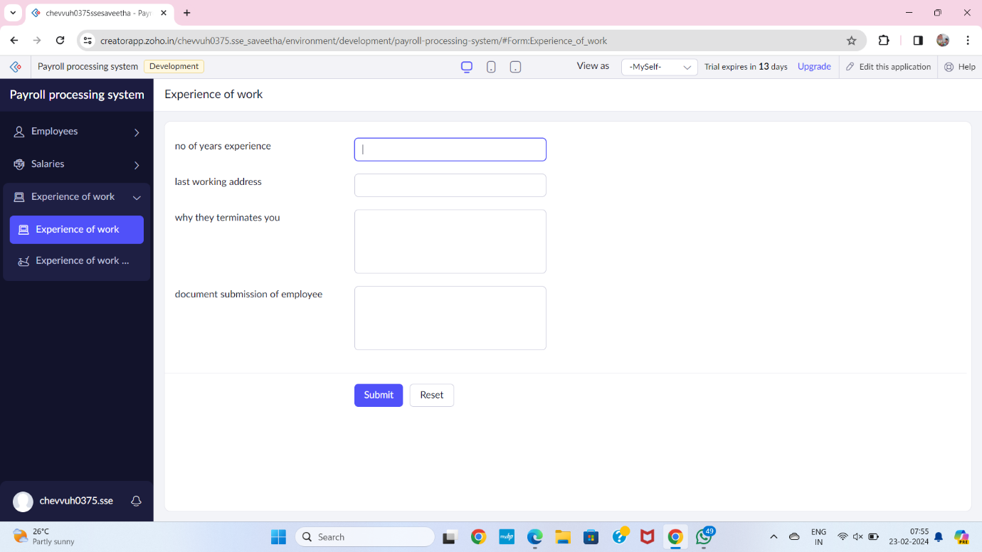

**STEP 10** THE SOFTWARE HASE BEEN CREATEDPAY ROLL IN COMPANY

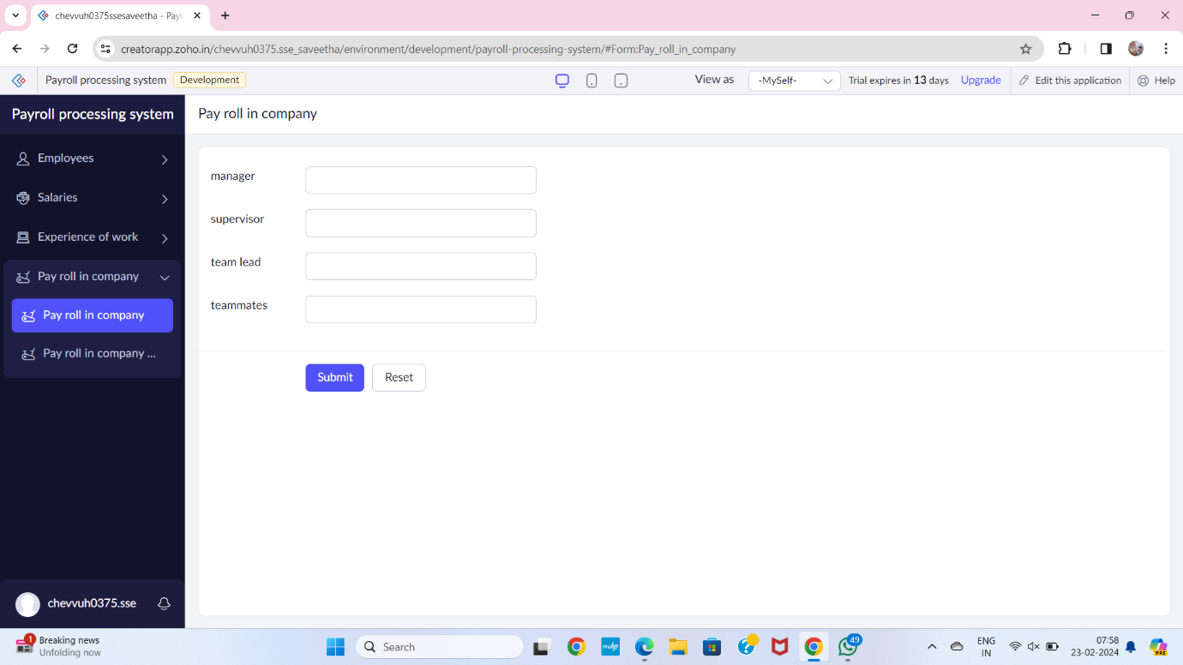

**STEP 11** THE SOFTWARE HASE BEEN CREATED

